Mathematics Policy
Safeguarding Statement
West Heath Primary will continuously strive to ensure that everyone in our school is treated with respect and dignity. Each person in our school will be given a fair and equal opportunity to develop their full potential with positive regard to gender, ethnicity, cultural and religious background, sexuality or disability. West Heath Primary School is committed to safeguarding and promoting the welfare of children and young people and expects all staff to share this commitment. Please also refer to the
No Platform, Visiting Speaker Policy.

Owner – CSTL
Date of review-February 2024
Date for review – July 2026
Mathematics Policy

Audience
This policy is designed to be used by teachers at West Heath Primary School to ensure that the expectations for the teaching of Mathematics are clear.

Equal Opportunities
At West Heath Primary School, we will continuously strive to ensure that everyone in our school is treated with respect and dignity. Each person in our school will be given fair and equal opportunity to develop to their full potential with positive regard to gender, ethnicity, cultural and religious background, disability or sexuality.

Aims
In line with the National Curriculum for Mathematics 2014, at West Heath Primary School, we aim to ensure that pupils:
- Have fluent arithmetic skills, appropriate to their age and stage, which they can use to reason and solve problems in a variety of contexts.
- Have a confident understanding of calculation, number, measurement, statistics and geometry.
- Understand the relevance of maths in the context of the real world and how they can use maths to support their everyday life.
- Have a positive attitude to Maths.

Procedure
EYFS
Mathematics within the EYFS is developed through purposeful, play-based experiences and will be represented throughout the indoor and outdoor provision. The learning will be based on the pupil's interests and the Development Matters/Early Years Outcomes. Mathematical understanding can be developed through stories, songs, games, imaginative play, child-initiated learning and structured teaching. The environment in EYFS has been set up to ensure the progressive development of mathematical skills.

Fact fluency is prioritised through the NCETM Mastering Number scheme. Short Maths inputs are given daily to introduce new concepts and implemented into continuous provision. In addition to this, other areas of mathematical learning, not covered in the NCETM's Mastering number scheme, such as shape and measure are mapped to ensure children are exposed to these key concepts before moving into year 1. In the classroom, equipment is labelled to show the quantity, shape, size (or calculation) and children are expected to ensure the correct number of items are returned to their place at tidy-up time.

KS1 and KS2
All children receive a daily Mathematics lesson, although mathematical skills run through many other areas of the curriculum. Each lesson has a clear learning outcome, which all children are expected to achieve. If children are working well below the national expected standard, then teachers are expected to use relevant lesson outcomes from previous year's learning, that are appropriate to the child. Children who are working at a greater standard are expected to be stretched and challenged through contextual problems and reasoning questions. At West Heath, we use a mastery approach focusing on the 5 big ideas, which are representation and structure, mathematical thinking, variation and fluency, with coherence threading through them all. Teachers must use the White Rose Maths Hub planning to complete their weekly written plans as well as Active Inspire boards to teach from. Quality first teaching is expected for all children; however, pre-teaching or small group teaching may be necessary at times. Children will work in mixed-ability pairs and groups to complete the work. On occasions, groups may be set due to need. This must be authorised by the Maths lead. Every classroom has a range of practical manipulatives and resources to support the children’s learning, with additional resources stored centrally. Children are encouraged to use manipulatives and resources to support their learning and it is essential that children always have access to these.

Long Term Planning
Figure 1: Long-term teaching overview

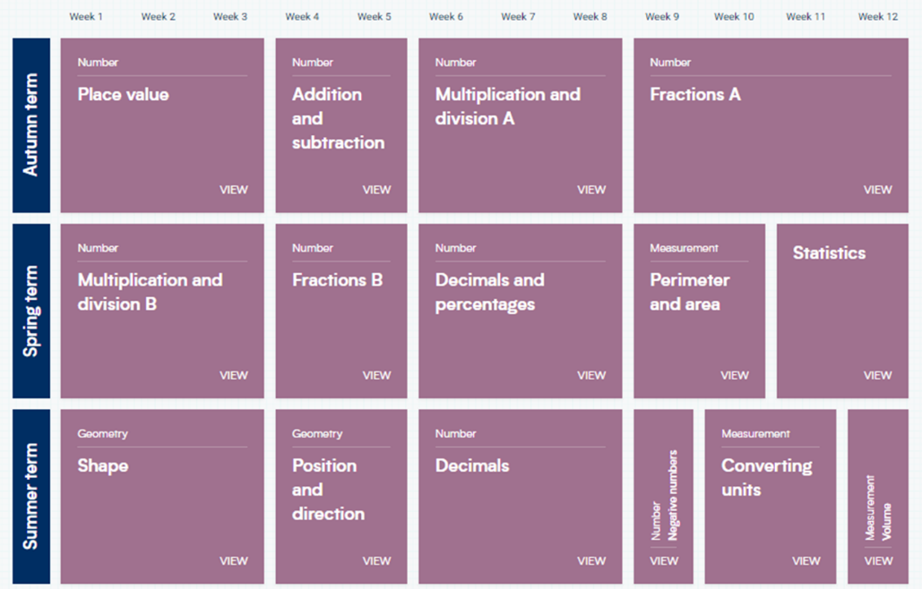
Long-term planning is produced by the White Rose Maths Hub. As a school we subscribe to this scheme and have access to all resources. Long-term planning outlines what units are covered in a year and how long is to be spent on each one.

Medium Term Planning

Medium-term planning is given to all teachers. This is taken from the White Rose Hub, but has been adapted to ensure that key teaching concepts are made explicit. Each unit of work contains a breakdown of the small steps needed to take to achieve the learning outcome (figure 2).The steps identify the teaching steps and the recommended amount of time to spend on each one. These small steps ensure that teachers do not teach too many concepts at once, which can lead to cognitive overload. These steps are linked to the national curriculum and ensure children cover all aspects of the curriculum. The units of work also give specific guidance on how each of the small steps should be delivered. These provided guidance on possible misconceptions, language and CPA models that could be used. Teachers also have access to the White Rose Maths Hub website, so that they can access resources to support them in the delivery of the curriculum. As a school we have also purchased the WRM professional development materials. Before planning a unit of work, teachers must access training videos. These give a clear breakdown of what the key learning is and concrete and pictorial resources that can be used to support children.

Figure 2: Small-step guidance
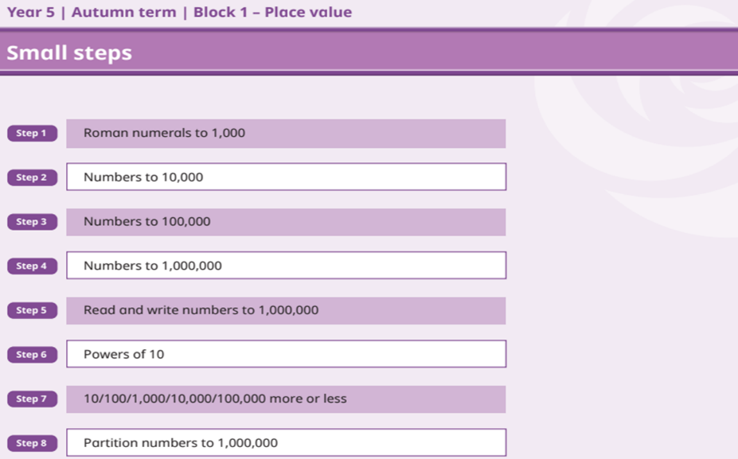

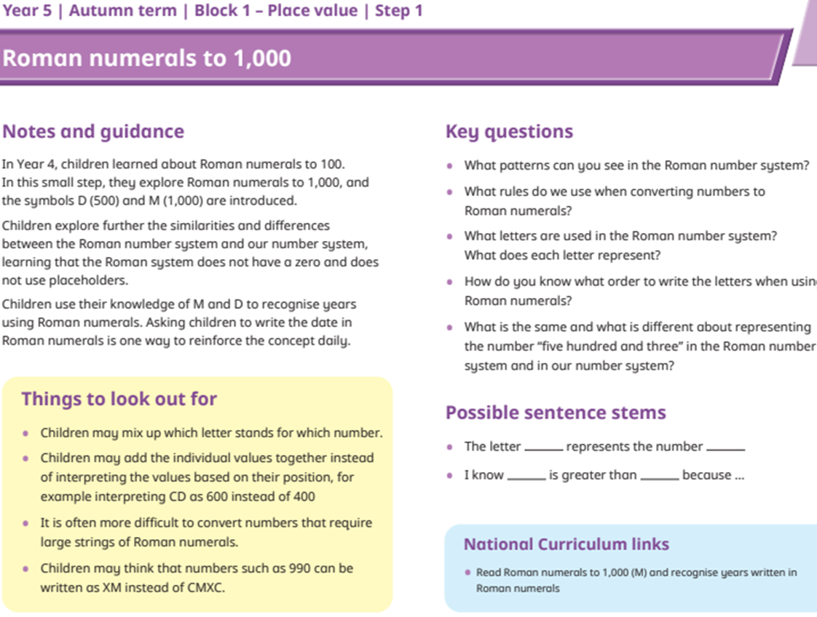
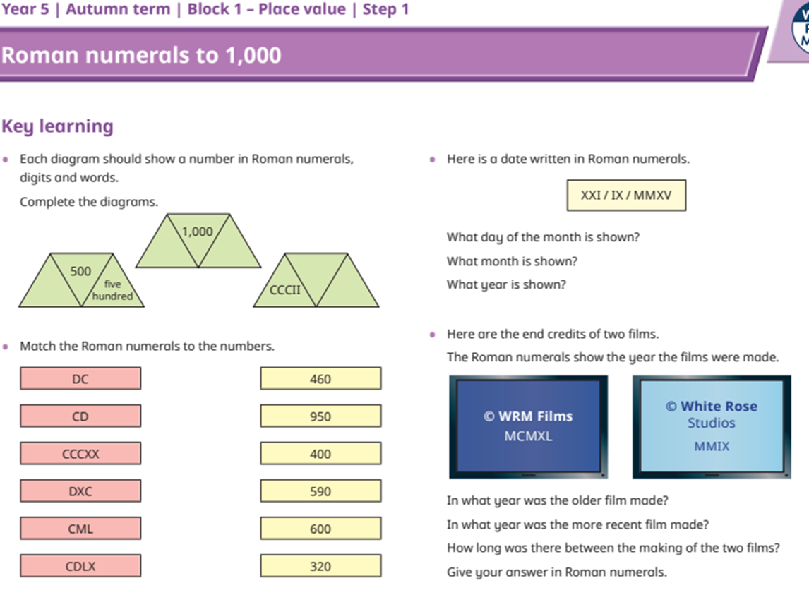

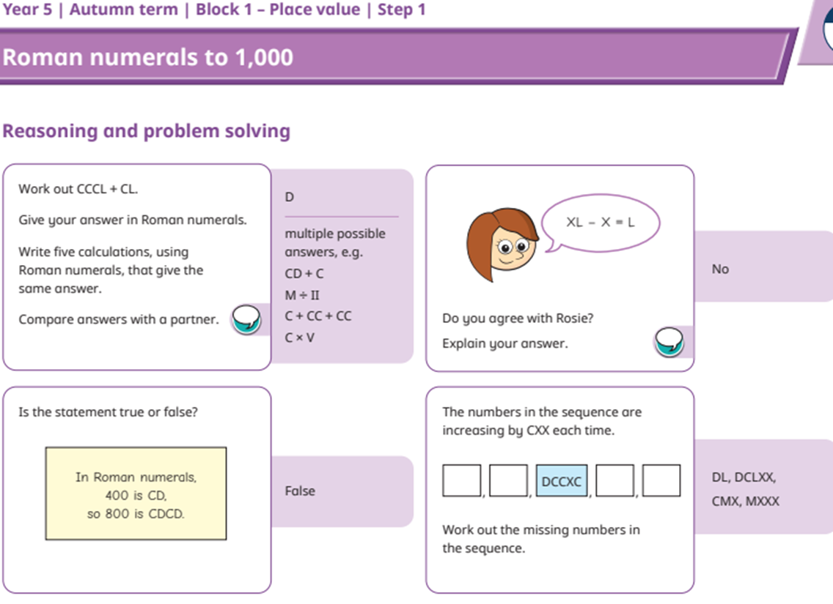

Short-Term Planning
Planning for maths is completed on ActiveInspire boards. Teachers are required to compile their teaching boards ensuring that they can be easily manipulated to illustrate concepts and ideas. Wherever possible the resources displayed on the board should be available to the children. These boards will be monitored by the maths lead prior to teachers using them for delivery. All lessons from Y1 to Y6 must follow the same general structure.

Lesson Structure

Five a day previously taught material
  - A question from the previous lesson
  - A question from the previous week
  - A question from the previous topic
  - A question from an area of maths you know the children find difficult.
  - A shape, space and measure-based question

Anchor Task- This must be a question that children can discuss and explore, that relates to the learning objective. This should be completed on whiteboards Teachers must ensure children have access to manipulatives and can show their answers in different ways. (5 to 10 minutes)
Main teaching- This is the direct teaching part of the lesson. Problems are modelled for children, they have guided practice using a clear scaffold. Children practice the skill taught, through further problems. Children should have access to whiteboards and pens, as well as manipulatives and other resources that help to illustrate the learning. This part of the lesson should follow an episodic style of teaching using the I, we, you model.
Independent work- Children should work independently on tasks related to the skills taught. Children identified during the lesson as needing further support will be directed to work with the teacher or TA. These groups are not set and will remain fluid.
End of lesson- Following the lesson books must be marked and teachers must take steps to address misconceptions. At KS2 same-day catch-up will be used. More details regarding this are given later in this policy.

Assessment
Children will receive regular feedback during lessons. This immediate verbal feedback should address misconceptions and provide opportunities for pupils to deepen their understanding. Children should not be grouped and should always be sat in mixed-ability pairs, unless express permission has been given by the maths lead.

The assessment of pupils is ongoing; class teachers ensure that assessment informs future planning, allowing for topics to be revisited if necessary. Teachers are expected to ensure work is marked with a tick if correct and a cross if it is wrong. This can be done by the teacher or by the pupils. If it has been marked by a pupil it is expected that teachers will check and use the information gained to inform future planning.

Maths Catch-Up
At KS2 Daily 20 20-minute sessions will take place. This is an opportunity for the teacher to work with any children who have not fully grasped the learning objective during the lesson. The teacher will take a small group and reteach a concept. The rest of the class will focus on gaining fluency in the year group expectations.

NCETM Mastering Number
In order to ensure that our children build firm foundations in number Years 1 and 2 will take part in daily mastering number sessions. These sessions are in addition to the daily maths lesson and use the NCETM materials.

Summative Assessment
In October, March and June of each year, children will undertake PUMA-standardised Mathematics tests. Following these tests, standardised scores will be calculated. Gaps in learning will be identified and interventions will be planned to ensure progress for all children. Effective use of pupil premium funding will be evaluated following each round of assessment. Provision for SEN pupils, LAC and those with EAL, will be evaluated termly.

Moderation and Monitoring
Teachers regularly moderate children's work to ensure accurate assessments. Children who are falling behind will be identified and interventions agreed upon with the Maths lead. The maths lead will also monitor books and use this to help support teaching and learning in the classroom.

The maths lead and SLT will monitor through observations, book scrutiny, pupil voice and learning walks.

Presentation
Orange books – a short date (KS2 using Roman numerals) and titles must be underlined, and a vertical two-square margin must be made with a ruler. Children must be taught to only ever record one digit per box and to use a ruler whenever creating a table. If worksheets are used this must be neatly stuck in and trimmed to fit.

Homework
Homework will be set on a Thursday and must be completed by Tuesday. Teachers will set homework using Mathletics, ensuring it links to the children's recent learning in class. Teachers can create groups to differentiate the homework as needed for their ability. Strikes are not to be given if homework is not completed, but teachers should encourage children to complete it to support their learning.

Times Tables Rock Stars
As a school we buy into Times Tables Rock Stars as a means of ensuring all of our children are fluent in their times tables up to x12. Children will spend at least 10 minutes a week on the program in school and are encouraged to log on daily at home. In order to increase participation, and to build upon the element of competition a leader board is displayed in school.

Monitoring of this policy:
This policy will be reviewed biannually by the maths lead and SLT

