Our Timetable
School opens for reading | 8.30 | 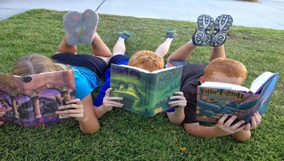
School starts  - Registration | 8.50  8.50
Assembly | 9.00
Lessons | 9.20 | 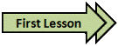
Lunchtime  - EYFS/KS1 lunchtime  - KS2 lunchtime | 11.30 -12.15  12.25- 1.15
School ends  - EYFS/KS1  - Y3/4  - Y5/6 | 3.00  3.05  3.10

